**Name – Parag Gattani**

Program No. – 01

Program Title – LED Blinking

**AIM**

Turn the LED on for a second, then off for a second, repeatedly.

**HARDWARES REQUIRED**

* Arduino Board
* LEDs

**CIRCUIT DIAGRAM**

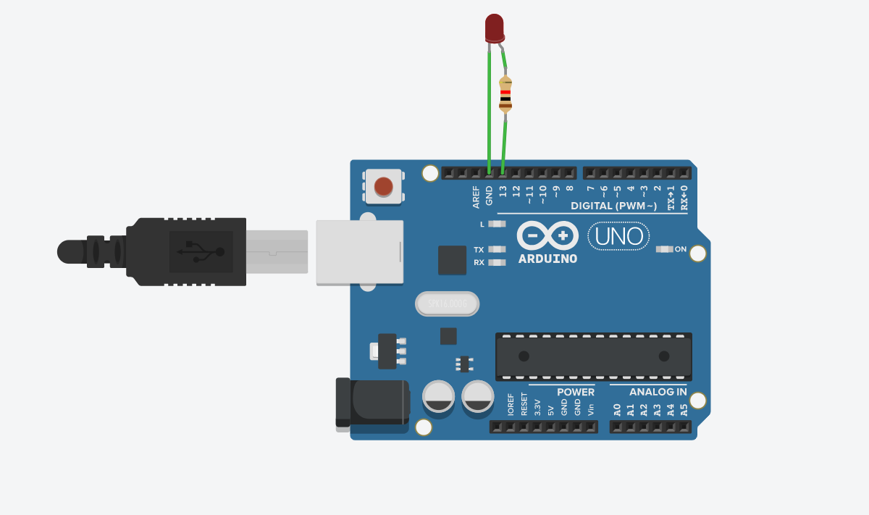

**WRITE-UP**

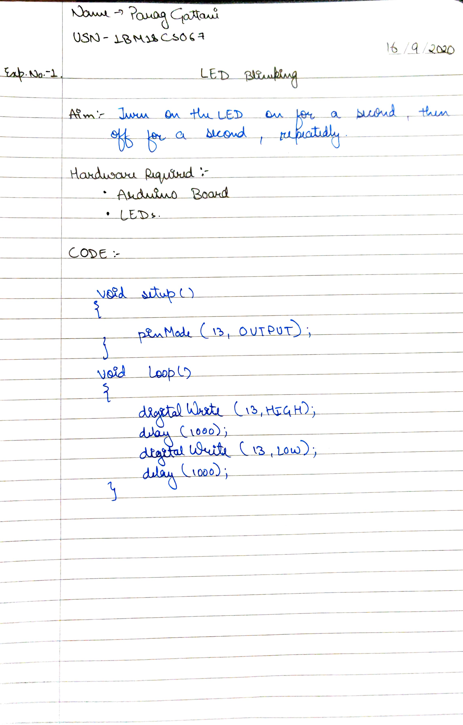

**CODE**

void setup()

{

pinMode(13, OUTPUT);

}

void loop()

{

digitalWrite(13, HIGH);

delay(1000); // Wait for 1000 millisecond(s)

digitalWrite(13, LOW);

delay(1000); // Wait for 1000 millisecond(s)

}

**OUTPUT**

The LED was found to be blinking at an interval of 1000 ms.